StudyBuddy: AI-Powered Study Assistant REST API

Project Description:
StudyBuddy harnesses Generative AI to turn a student's own study notes into an interactive learning experience through a secure REST API. Users register and log in, upload their study material as a text file, and then ask the AI to work on it. The platform includes a Material Manager, which stores and retrieves uploaded notes for each user; a Summarizer, which condenses the material into a clear topic-wise summary; a Flashcard Generator, which creates question-and-answer cards for quick revision; and a Study Plan Generator, which builds a personalized day-by-day schedule based on the material.
Utilizing Groq's API with the LLaMA 3.3-70B Versatile model, StudyBuddy processes the uploaded content to deliver fast, high-quality study aids. Built with Node.js and Express, backed by MongoDB, and secured with JWT-based authentication (access and refresh tokens) and role-based users (student and admin), the platform ensures every user's material stays private. With secure key management via .env and strict request handling, StudyBuddy empowers students, teachers, and ed-tech developers to learn and build with confidence.

Scenarios
Scenario 1: A new student registers with the role "student", logs in, and uploads a Node.js beginner notes file (nodejs.txt). The API stores the file content in MongoDB against the student's account and returns a "Material uploaded" confirmation with the material details.
Scenario 2: Before an exam, the student selects the uploaded material and requests a summary. The API sends the stored content to the AI model and returns a topic-organized summary covering fundamentals, modules, file system, and web development, so the student can revise the whole syllabus in minutes.
Scenario 3: The student then generates flashcards for active recall and a 7-day study plan of 2 hours per day. The API returns question-and-answer cards and a day-wise plan with time blocks for theory, hands-on coding, and retention practice.

Technical Architecture:
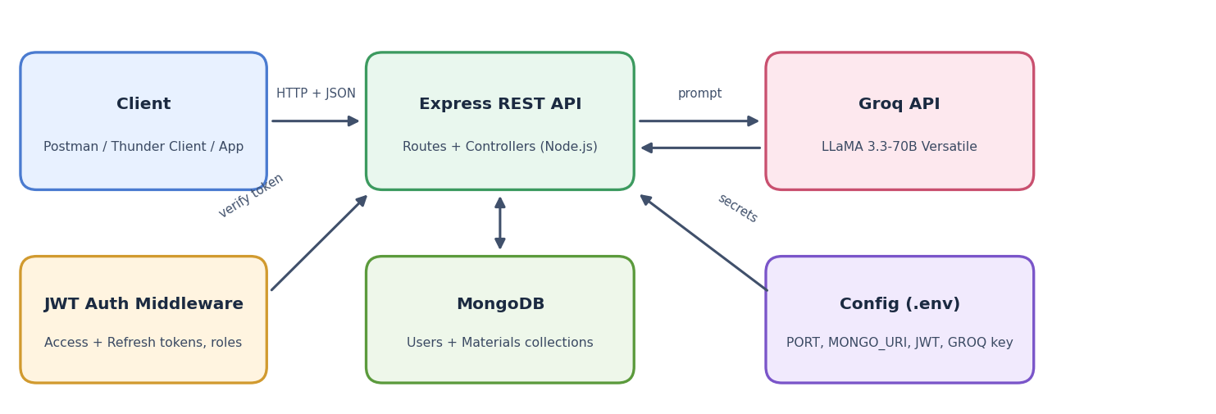
Description: StudyBuddy follows a modular, layered architecture. Clients such as Postman, Thunder Client, or any web or mobile app send JSON or form-data requests to the Express REST API. Protected routes first pass through a JWT authentication middleware that verifies the bearer token and the user's role. The controllers then read or write user and material data in MongoDB, and for AI features they build a prompt from the stored material and send it to the Groq API using the LLaMA 3.3-70B model. Secrets such as the database URI, JWT secrets, and the Groq API key are kept in a .env file and never hard-coded.

Database Design (ER Description):
The project uses MongoDB with two collections connected by a one-to-many relationship: one User can own many Materials.
Collection | Fields | Description
User | _id, name, email, password (hashed), role, refreshToken, createdAt | Stores registered users. Role is either student or admin.
Material | _id, user (ref to User), title, filename, content, createdAt, updatedAt | Stores each uploaded study file, its text content, and the owner.

Pre-requisites:
- Node.js and Express Knowledge: Express Documentation
- MongoDB and Mongoose: Mongoose Documentation
- JWT Authentication: jwt.io Introduction
- Groq API Familiarity: Groq API Documentation
- JavaScript Proficiency: MDN JavaScript Guide
- API Testing Tools: Postman Learning Center
- Version Control with Git: Git Documentation
- Environment Variables: dotenv Documentation

Project Workflow:

Milestone 1: Model Selection and Architecture
- Activity 1.1: Generate a Groq API key and configure it securely in the project environment.
- Activity 1.2: Research and select the appropriate generative AI model from Groq for study-content generation.
- Activity 1.3: Define the architecture, detailing interactions between the client, Express API, MongoDB, and AI integration.
- Activity 1.4: Set up the development environment and install the required Node.js packages.

Milestone 2: Authentication and Material Management
- Activity 2.1: Implement user registration, login, and logout with JWT access and refresh tokens.
- Activity 2.2: Implement material upload, listing, and retrieval, protected by the auth middleware.

Milestone 3: AI Features Development
- Activity 3.1: Build the AI service and implement the Summarize, Flashcards, and Study Plan endpoints.

Milestone 4: API Testing
- Activity 4.1: Test the authentication endpoints using Thunder Client in VS Code.
- Activity 4.2: Test the material and AI endpoints using Postman with Bearer token authorization.

Milestone 5: Deployment
- Activity 5.1: Prepare the application and run it locally with nodemon.
- Activity 5.2: Optionally expose the local server publicly using Ngrok.

Milestone 6: Conclusion

Milestone 1: Model Selection and Architecture
In this milestone, we select the generative AI model from Groq that will power the study features and define how the different parts of the system communicate. We also prepare the development environment so that the rest of the milestones can be built on a stable foundation.

Activity 1.1: Generate a Groq API Key
Before the application can communicate with the Groq LLM, you need a valid Groq API key. Follow the steps below to create one and connect it securely to the project.
- Step 1: Create a Groq Account. Visit https://console.groq.com and sign up for a free account using your Google account or email address.
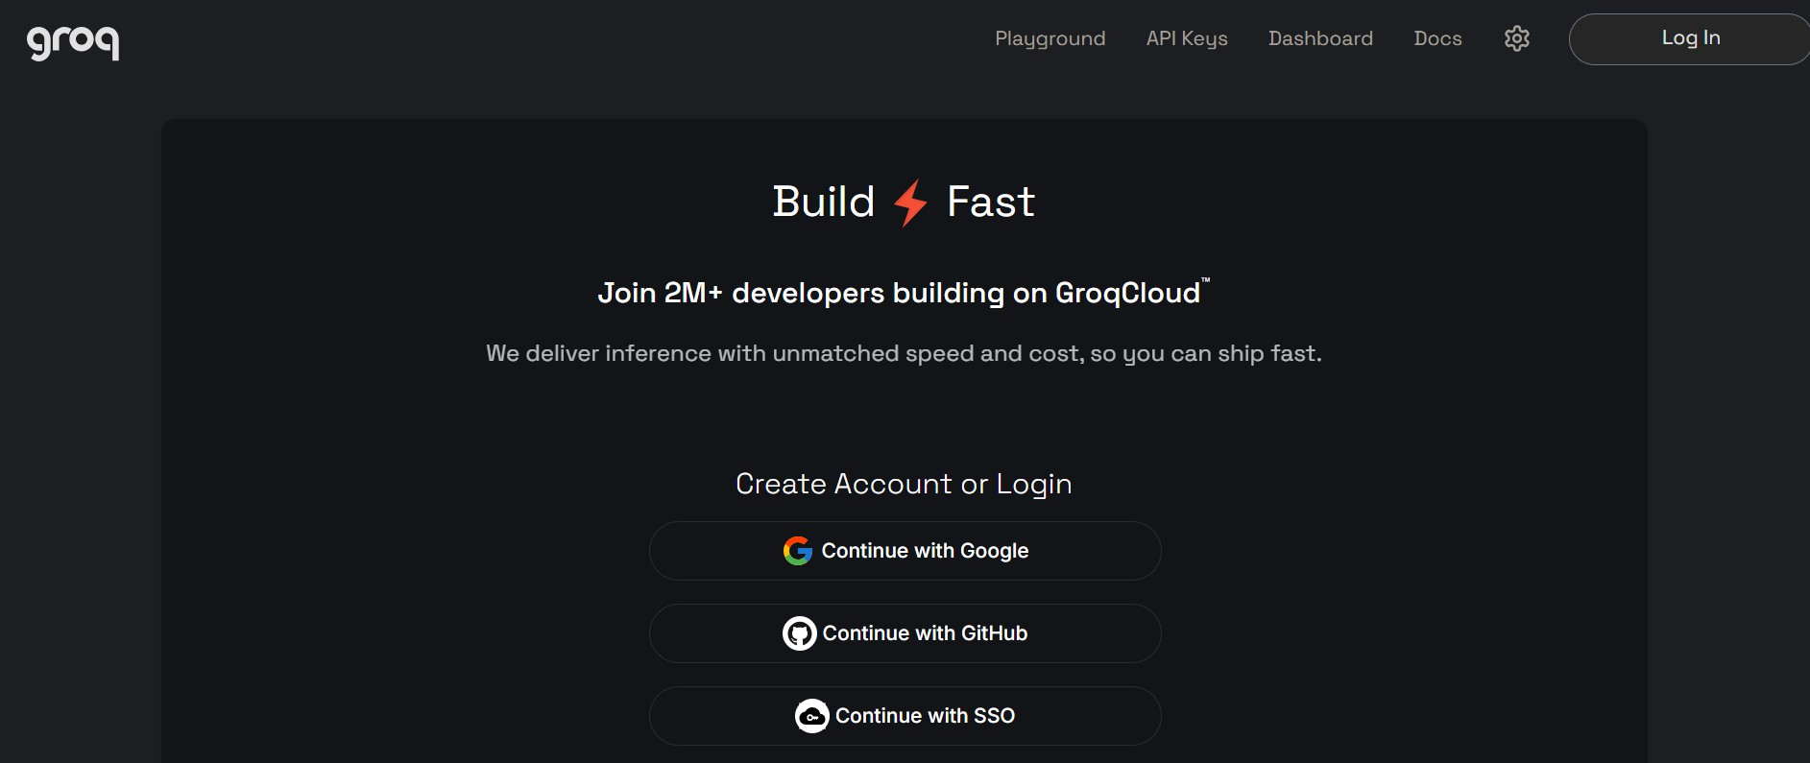
Groq console: sign-up / login page
- Step 2: Navigate to API Keys. After logging in, open the "API Keys" section from the menu.
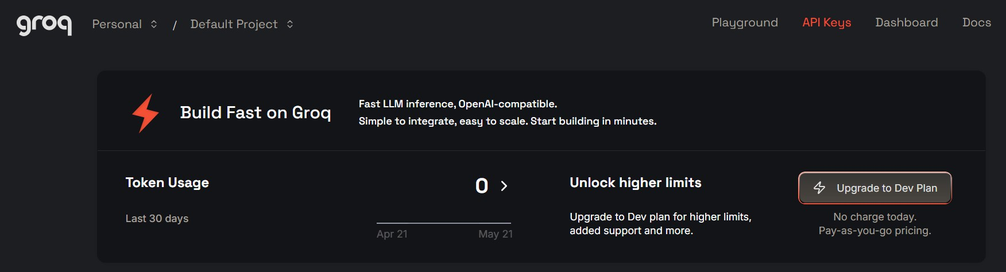
Groq console: opening the API Keys page
- Step 3: Create a New API Key. Click "Create API Key", give it a descriptive name (for example, studybuddy-key), and click Submit.
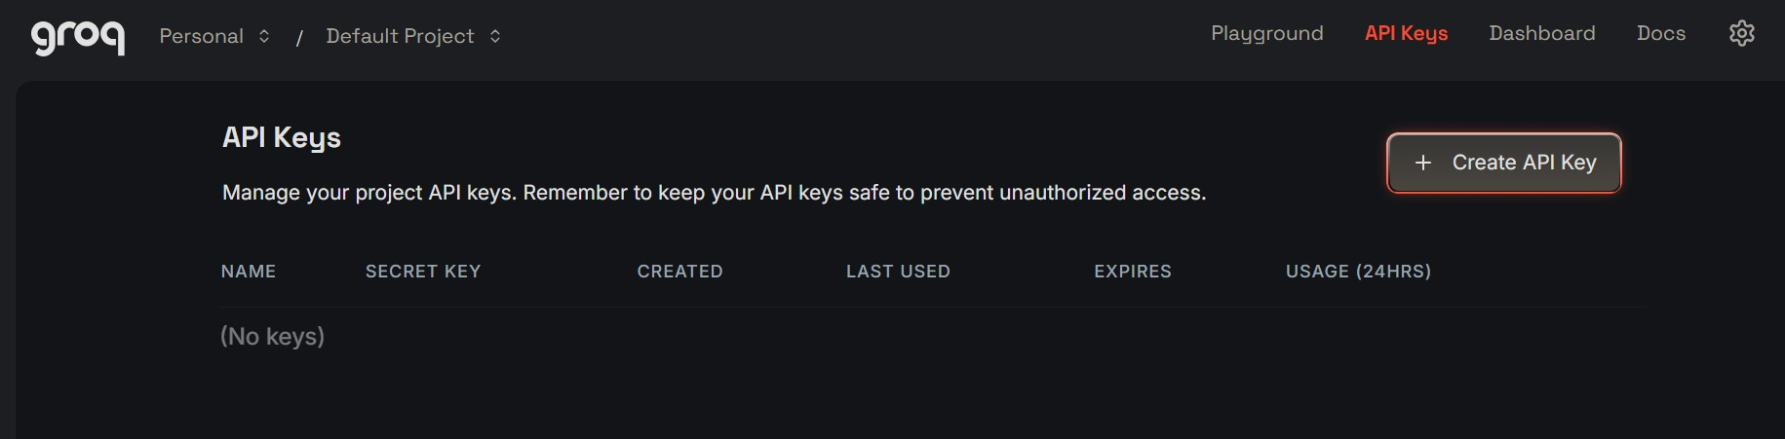
Groq console: Create API Key button
- Step 4: Copy the Key. Copy the key immediately and store it safely. You will not be able to view it again after closing the dialog.
- Step 5: Add the Key to Your Project. Create a .env file in the project root and add your configuration values:
PORT=5000
MONGO_URI=mongodb://localhost:27017/studybuddy
JWT_ACCESS_SECRET=your_access_secret
JWT_REFRESH_SECRET=your_refresh_secret
GROQ_API_KEY=your_copied_api_key_here
GROQ_MODEL=llama-3.3-70b-versatile

- Important: Never commit your secrets. Add .env and node_modules to your .gitignore file:
.env
node_modules/
uploads/

Activity 1.2: Research and Select the Appropriate Generative AI Model
- Understand the Project Requirements: The model must handle long study notes and produce structured summaries, flashcards, and multi-day study plans.
- Explore Groq's Model Documentation: Review the available models, their context windows, speed, and limitations.
- Evaluate Model Performance: Compare models on factual accuracy, response quality, speed, and ability to follow formatting instructions.
- Select the Optimal Model: Choose llama-3.3-70b-versatile for its balance of accuracy and speed, with a temperature of about 0.5 to keep educational content factual.

Activity 1.3: Define the Architecture of the Application
- Draft an Architectural Diagram showing the client, Express API, JWT middleware, MongoDB, and Groq API.
- Detail Client Interaction: Users register or log in, receive tokens, upload a study file, and call AI endpoints with the material ID.
- Outline Backend Responsibilities: The Express backend validates requests, verifies JWT tokens and roles, stores data in MongoDB, and calls the AI service.
- Describe AI Integration Points: Each AI endpoint loads the user's material from MongoDB, builds a task-specific prompt (summary, flashcards, or study plan), calls Groq, and returns the result.

Activity 1.4: Set Up the Development Environment
- Install Node.js and MongoDB: Ensure Node.js (v18 or above) and MongoDB are installed and MongoDB is running locally.
- Initialize the Project:
npm init -y

- Install the Required Packages:
npm install express mongoose dotenv cors bcryptjs jsonwebtoken multer groq-sdk
npm install --save-dev nodemon

- Set Up Application Structure: Create the project folders as shown below.
StudyBuddy/
|-- server.js
|-- index.js # Express app and routes registration
|-- .env
|-- package.json
|-- config/db.js
|-- models/
| |-- User.js
| `-- Material.js
|-- middleware/
| |-- auth.js
| `-- upload.js
|-- routes/
| |-- auth.js
| `-- materials.js
|-- controllers/
`-- services/ai.js

Milestone 2: Authentication and Material Management
This milestone builds the secure foundation of the API: user accounts with hashed passwords, JWT-based authentication, and the ability to upload and manage study materials that belong to each user.

Activity 2.1: Implement User Authentication
- Register: Accepts name, email, password, and role (student or admin). The password is hashed with bcrypt before saving, and the API returns an access token, a refresh token, and the user details.
- Login: Verifies the email and password and issues a new pair of tokens.
- Logout: Invalidates the user's refresh token so it can no longer be used to obtain new access tokens.
- Auth Middleware: Reads the Bearer token from the Authorization header, verifies it, and attaches the user to the request. Requests without a valid token receive a 401 error.
// middleware/auth.js
const jwt = require('jsonwebtoken');

module.exports = (req, res, next) => {
const header = req.headers.authorization || '';
const token = header.startsWith('Bearer ') ? header.split(' ')[1] : null;
if (!token) return res.status(401).json({ message: 'No token provided' });
try {
req.user = jwt.verify(token, process.env.JWT_ACCESS_SECRET);
next();
} catch (err) {
res.status(401).json({ message: 'Invalid or expired token' });
}
};

Activity 2.2: Implement Material Upload and Retrieval
Uploaded study files are read as text and stored in MongoDB together with the owner's user ID, so every user can only access their own materials.
Method | Endpoint | Purpose | Auth
POST | /api/auth/register | Create a new account and receive tokens | No
POST | /api/auth/login | Log in and receive tokens | No
POST | /api/auth/logout | Log out and invalidate the refresh token | No
POST | /api/materials/upload | Upload a study file (form-data: file, title) | Bearer
GET | /api/materials/ | List the logged-in user's materials | Bearer
GET | /api/materials/:id | Get one material with its full content | Bearer
POST | /api/materials/:id/summarize | AI summary of the material | Bearer
POST | /api/materials/:id/flashcards | AI flashcards from the material | Bearer
POST | /api/materials/:id/study-plan | AI day-wise study plan | Bearer

// models/Material.js
const mongoose = require('mongoose');

const materialSchema = new mongoose.Schema({
user: { type: mongoose.Schema.Types.ObjectId, ref: 'User', required: true },
title: { type: String, required: true },
filename: { type: String },
content: { type: String, required: true },
}, { timestamps: true });

module.exports = mongoose.model('Material', materialSchema);

Milestone 3: AI Features Development
Milestone 3 connects the stored study material to the Groq LLM. A single AI service handles the communication with Groq, and each endpoint supplies its own task-specific prompt.

Activity 3.1: Build the AI Service and Feature Endpoints

Create the AI Service:
// services/ai.js
const Groq = require('groq-sdk');
const groq = new Groq({ apiKey: process.env.GROQ_API_KEY });

async function askAI(systemMsg, userMsg) {
const res = await groq.chat.completions.create({
model: process.env.GROQ_MODEL || 'llama-3.3-70b-versatile',
messages: [
{ role: 'system', content: systemMsg },
{ role: 'user', content: userMsg },
],
temperature: 0.5,
max_tokens: 2048,
});
return res.choices[0].message.content;
}

module.exports = { askAI };

Implement the Feature Endpoints:
- Summarize: Loads the material, asks the AI for a clear, topic-organized summary, and returns { summary }.
- Flashcards: Asks the AI for concise question-and-answer cards and returns { flashcards: [{ question, answer }] }. The reply is parsed as JSON before it is sent to the client.
- Study Plan: Reads the requested number of days and hours per day, asks the AI for a personalized plan with time blocks, and returns { studyPlan }.
// routes/materials.js (excerpt)
router.post('/:id/summarize', auth, async (req, res) => {
const material = await Material.findOne({ _id: req.params.id, user: req.user.id });
if (!material) return res.status(404).json({ message: 'Material not found' });

const summary = await askAI(
'You are a helpful study assistant.',
`Summarize this study material clearly, organized by topic:\n\n${material.content}`
);
res.json({ summary });
});

- Every route checks that the material belongs to the logged-in user (user: req.user.id), so one student can never read another student's notes.

Milestone 4: API Testing
Since StudyBuddy is a backend API, it is tested with API clients instead of a browser interface. Thunder Client (inside VS Code) is used for the authentication endpoints, and Postman is used for the material and AI endpoints with Bearer token authorization.

Activity 4.1: Start the Server and Test Authentication

Start the Server:
npm start

The terminal shows nodemon starting the server, the environment variables being loaded, "MongoDB connected: localhost", and "Server running on port 5000".

Register a Student:
Send a POST request to /api/auth/register with name, email, password, and role set to "student". A successful registration returns 201 Created with a success message, an access token, a refresh token, and the user details.
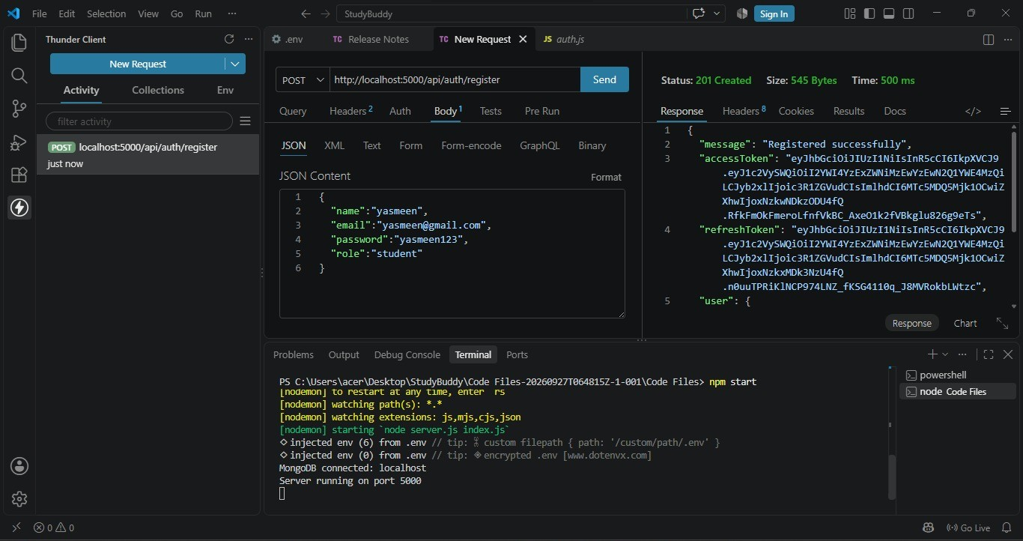
Thunder Client: registering a student (201 Created) with the server running in the terminal

Register an Admin:
The same endpoint with role set to "admin" creates an admin account, showing that the API supports role-based users.
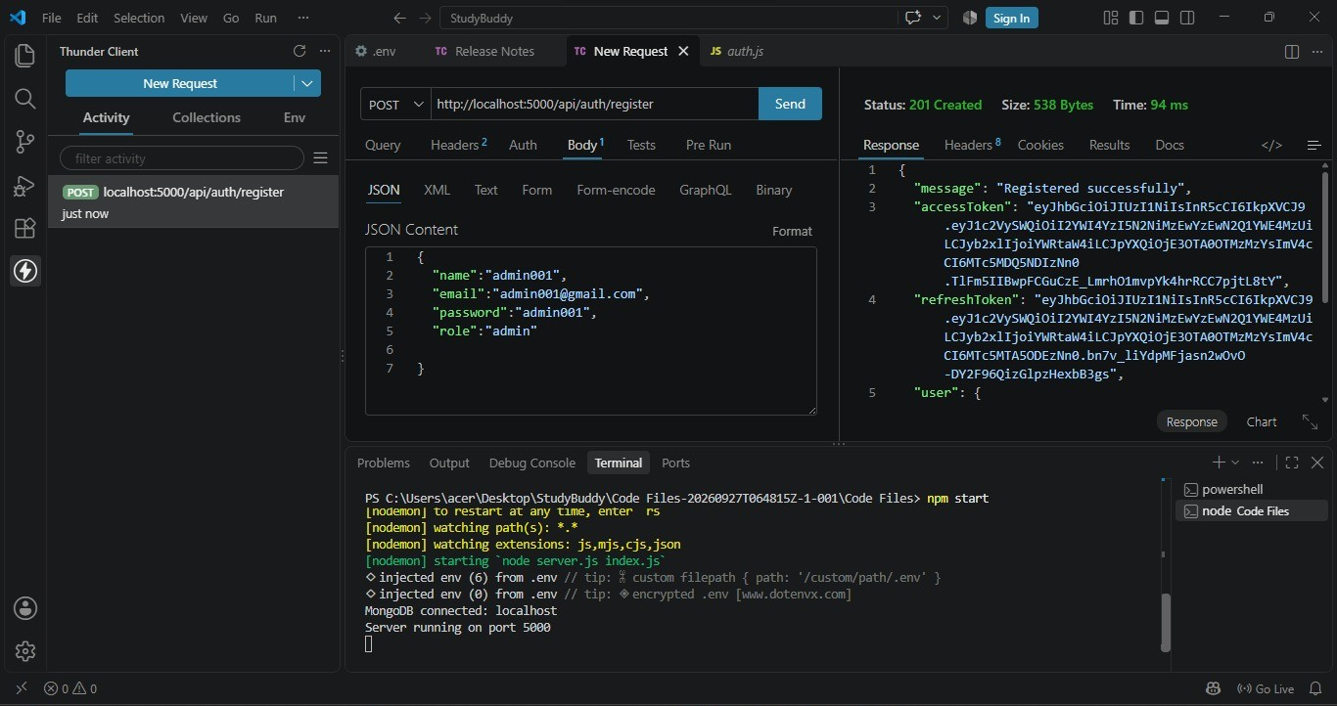
Thunder Client: registering an admin user (201 Created)

Log Out:
Send a POST request to /api/auth/logout. The API responds with 200 OK and the message "Logged out".
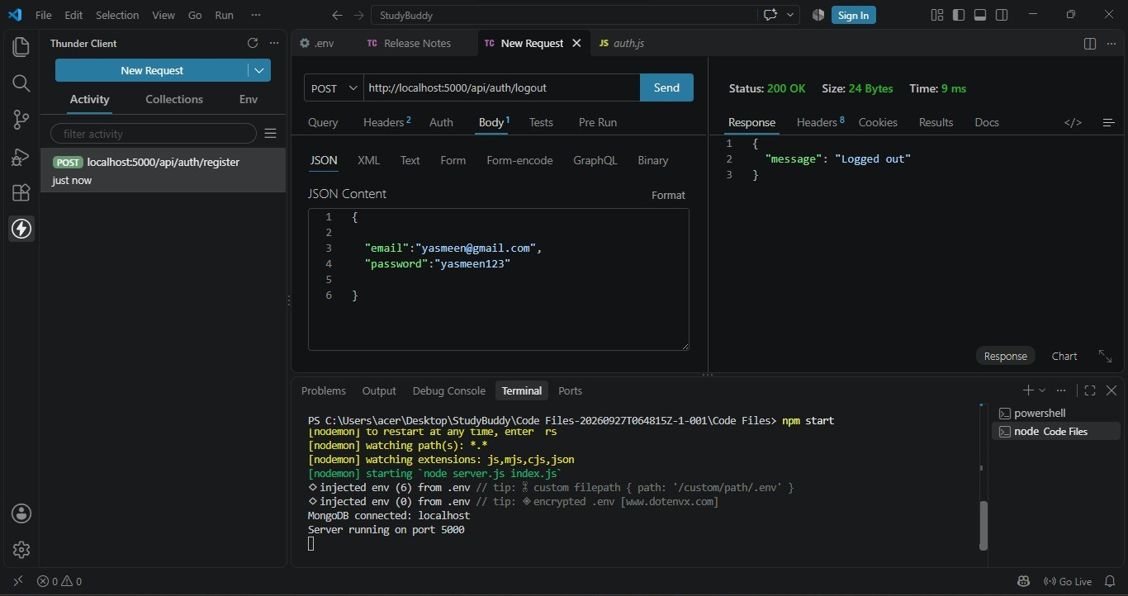
Thunder Client: logout request returning 200 OK

Activity 4.2: Test Material and AI Endpoints
For the following requests, open the Authorization tab in Postman, choose "Bearer Token", and paste the access token received at login.

Upload a Study Material:
Send a POST request to /api/materials/upload with form-data containing a file (nodejs.txt) and a title. The API returns 201 Created with the message "Material uploaded" and the saved material.
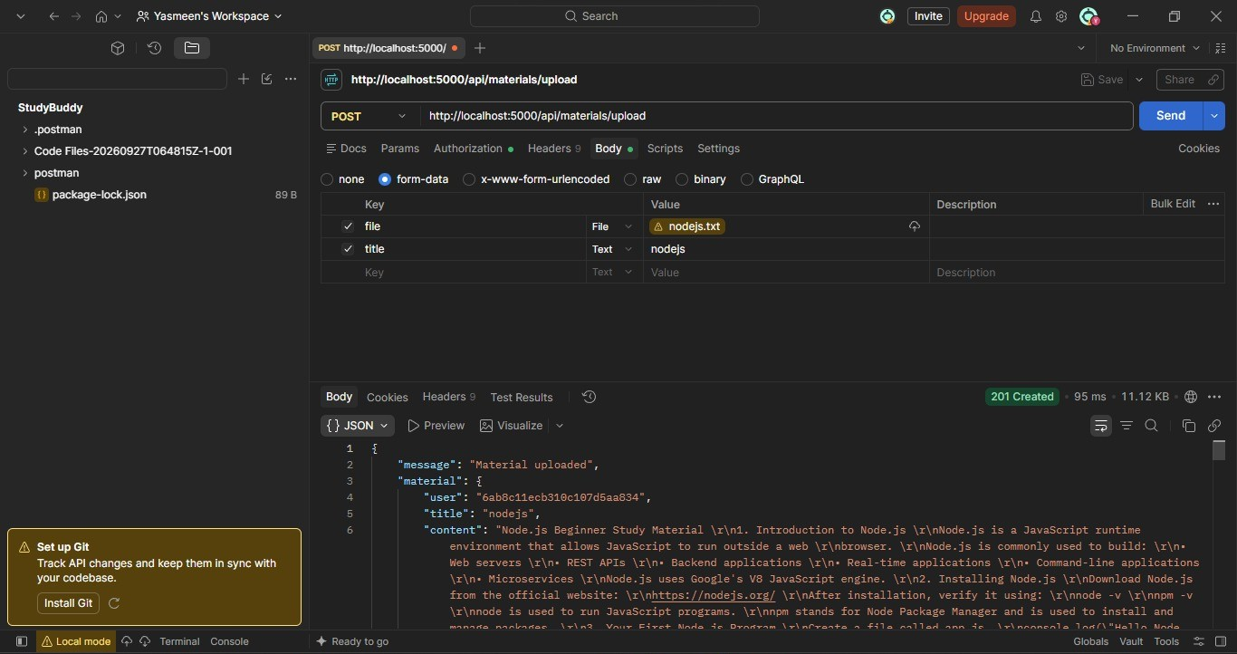
Postman: uploading nodejs.txt as a study material (201 Created)

List All Materials:
A GET request to /api/materials/ returns the logged-in user's materials with their ID, title, filename, and timestamps. The large content field is left out of the list to keep the response light.
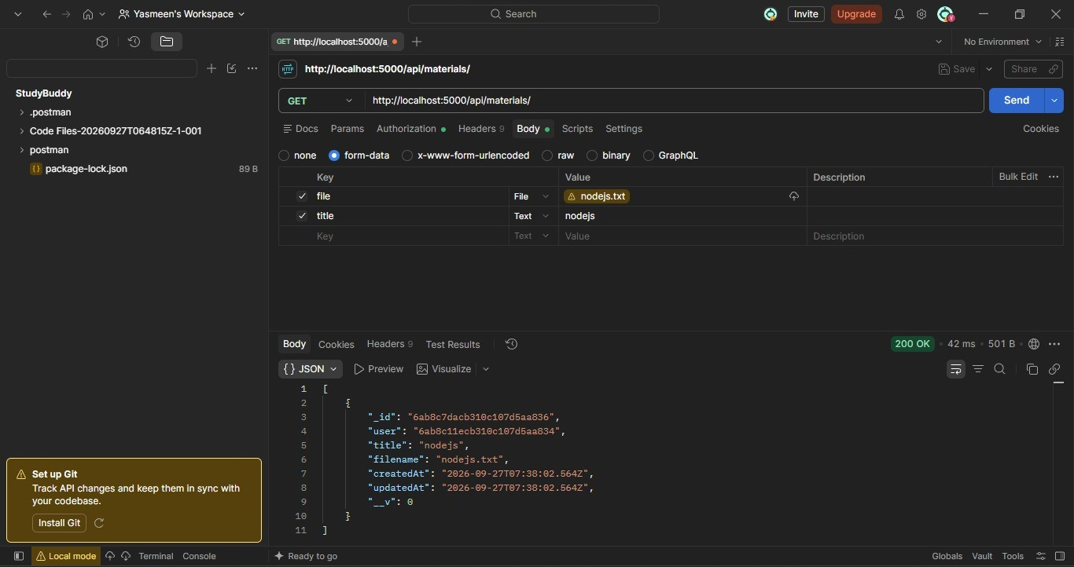
Postman: listing the user's uploaded materials (200 OK)

Get a Material by ID:
A GET request to /api/materials/:id returns the complete material including its stored text content.
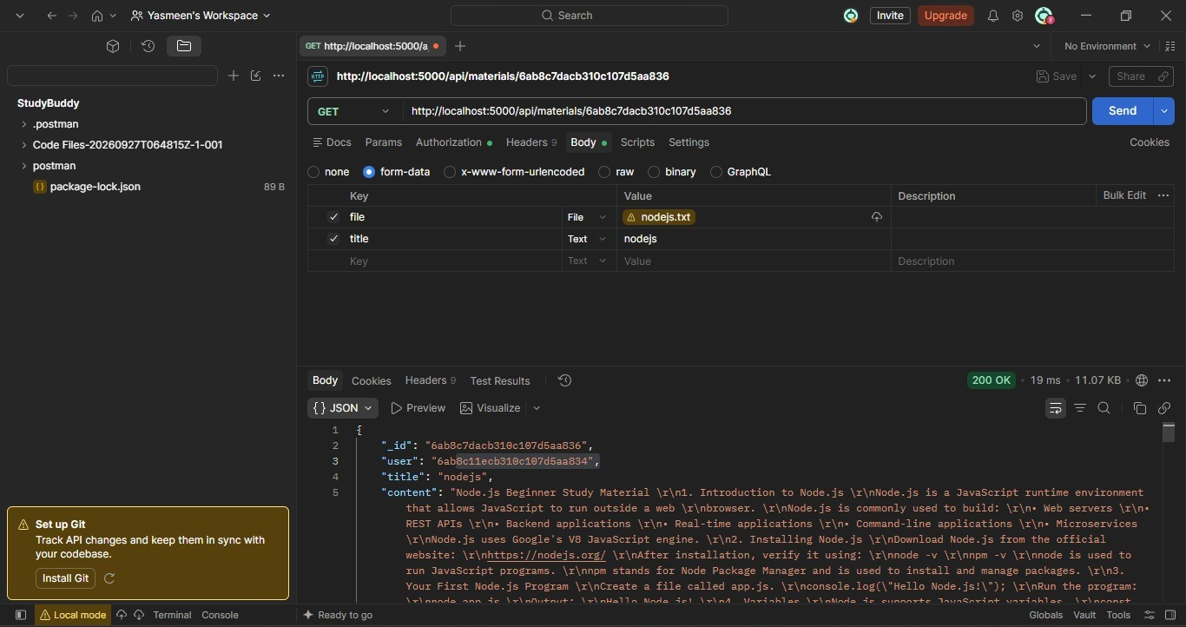
Postman: fetching one material with its full content (200 OK)

Summarize the Material:
A POST request to /api/materials/:id/summarize sends the stored content to the AI model and returns a structured summary organized by topic.
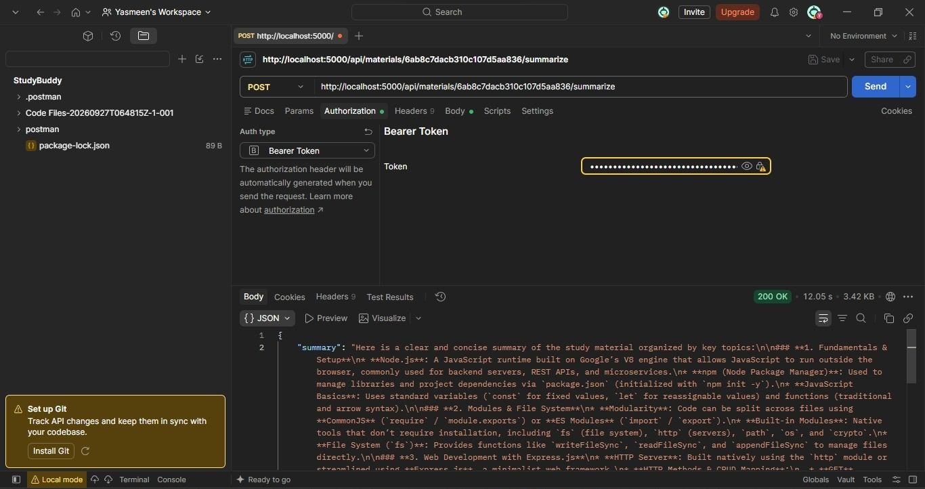
Postman: AI-generated summary of the material (200 OK)

Generate Flashcards:
A POST request to /api/materials/:id/flashcards returns a list of flashcards, each with a question and an answer, ready for revision.
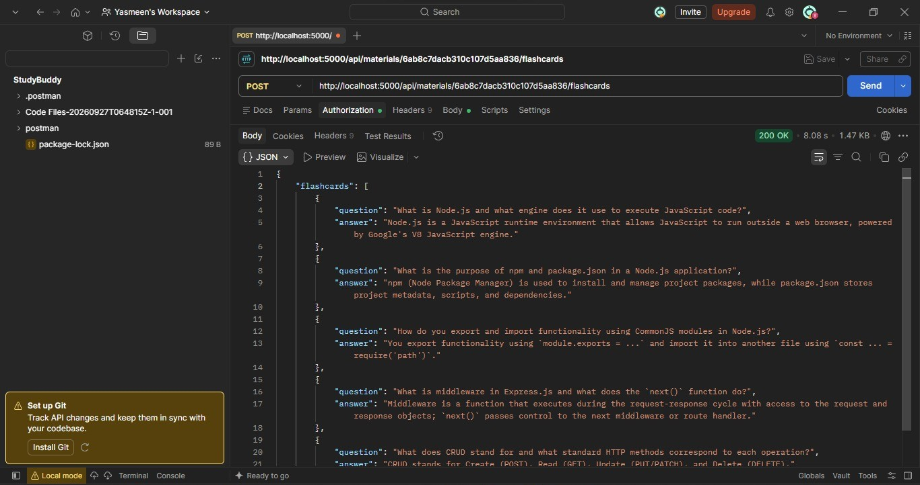
Postman: AI-generated flashcards (200 OK)

Generate a Study Plan:
A POST request to /api/materials/:id/study-plan returns a personalized plan, for example a 7-day schedule with 2 hours per day, divided into theory, hands-on coding, and retention practice.
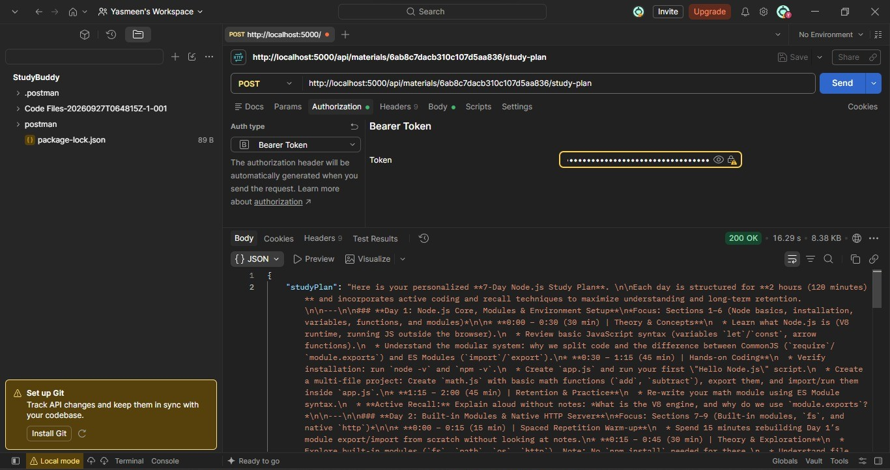
Postman: AI-generated 7-day study plan (200 OK)
- Also test invalid cases such as a missing token (401), a wrong material ID (404), and a missing file or title (400) to confirm the error responses.

Milestone 5: Deployment
In Milestone 5, the application is run locally to confirm that every endpoint works, and can then be exposed publicly through Ngrok so that others can test the API.

Activity 5.1: Preparing the Application for Local Deployment
- Install all dependencies from package.json:
npm install

- Add a start script to package.json so that the server restarts automatically when files change:
"scripts": {
"start": "nodemon server.js"
}

- Make sure MongoDB is running and the .env file contains all required values, then start the server:
npm start

- The API is now available at http://localhost:5000.

Activity 5.2: Public Deployment via Ngrok (Optional)
Ngrok creates a secure tunnel from a public URL to your local Express server, so the API can be shared without a cloud hosting provider.
- Download and install Ngrok from https://ngrok.com/download and add your authtoken:
ngrok config add-authtoken YOUR_AUTHTOKEN

- With the server running on port 5000, start the tunnel:
ngrok http 5000

Important Notes:
- On the free Ngrok plan, the public URL changes each time you restart the tunnel.
- Anyone with the URL can call your API, so keep authentication enabled and stop the tunnel when you are not demonstrating the project.
- Never share your .env file or expose your Groq API key or JWT secrets.

Conclusion:
StudyBuddy is a generative AI study assistant built as a secure REST API with Node.js, Express, and MongoDB. It uses JWT authentication with role-based users to protect each student's data, and Groq's high-speed inference API with the LLaMA 3.3-70B Versatile model to turn uploaded study notes into summaries, revision flashcards, and personalized study plans. The project, which covered model selection, authentication, material management, AI integration, API testing, and deployment, shows how a well-structured backend and carefully written prompts can make learning more efficient.
Looking ahead, StudyBuddy can be extended with support for PDF and DOCX uploads, quiz generation with automatic scoring, progress tracking and study history, a React or mobile front end, refresh-token rotation, rate limiting on AI endpoints, and cloud deployment. With these improvements, the platform can grow from a focused study tool into a complete personalized learning assistant for students and educators.

